INF1103 Lab 6
Note I put it as lab 8, but it is actually lab 6
GitHub Repository Link: https://github.com/SYnthestic/INF1103lab2
Screenshots
Scenario | Screenshot
Docker Build | 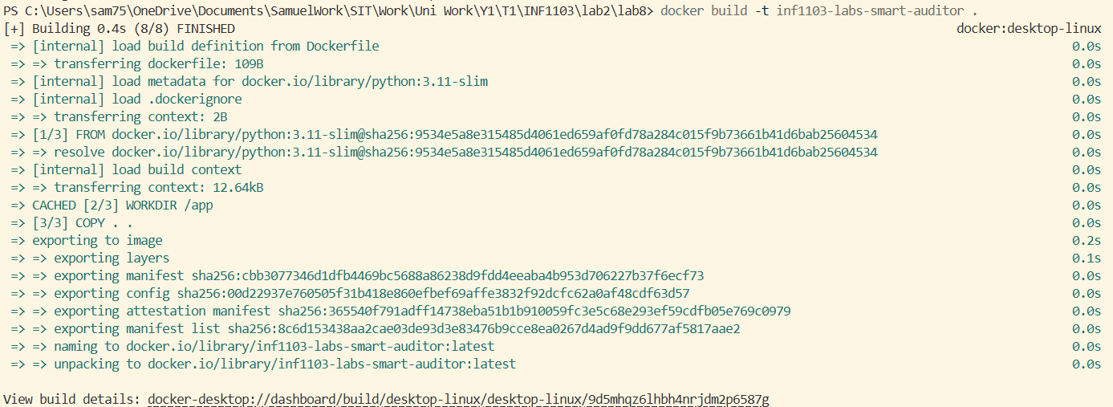
Docker Images | 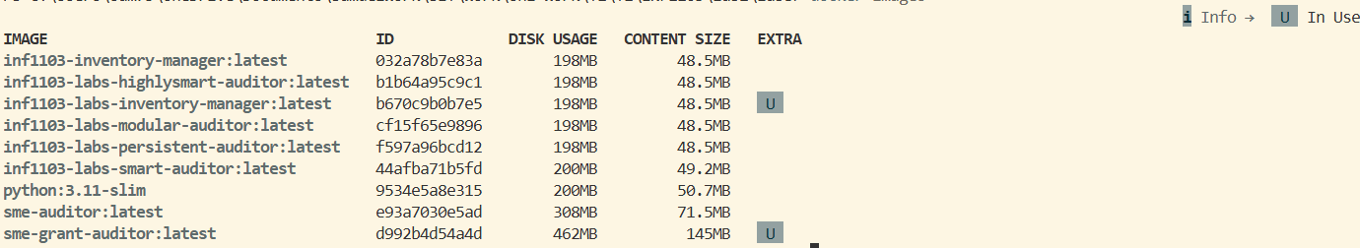
Docker Run | 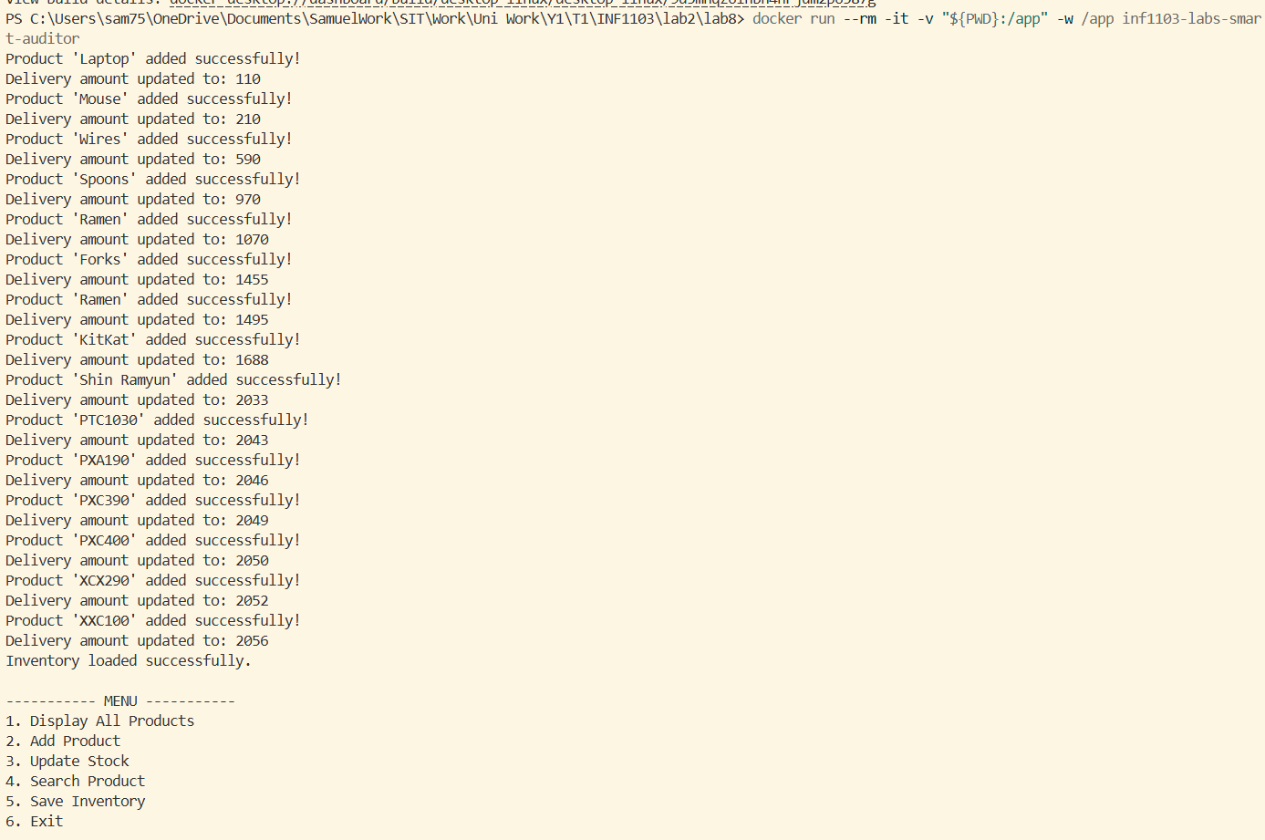
Docker Accepting Input and Output (Options 1 and 2) | 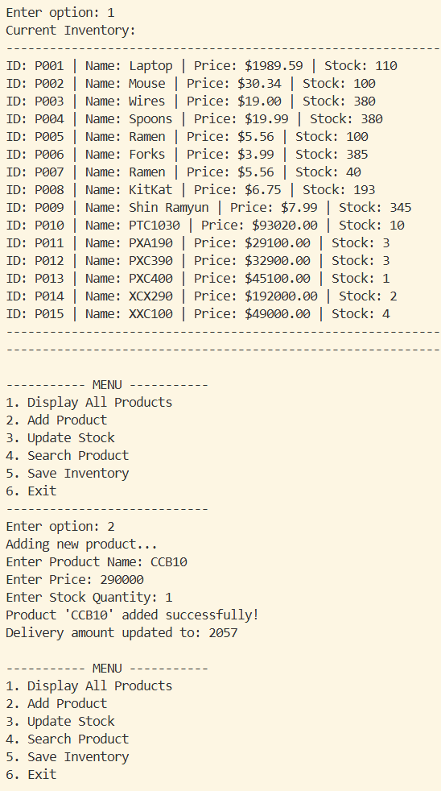
Docker Accepting Input and Output (Option 3) | 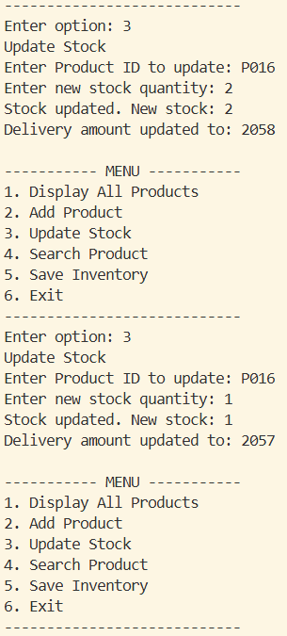
Docker Accepting Input and Output (Option 4) | 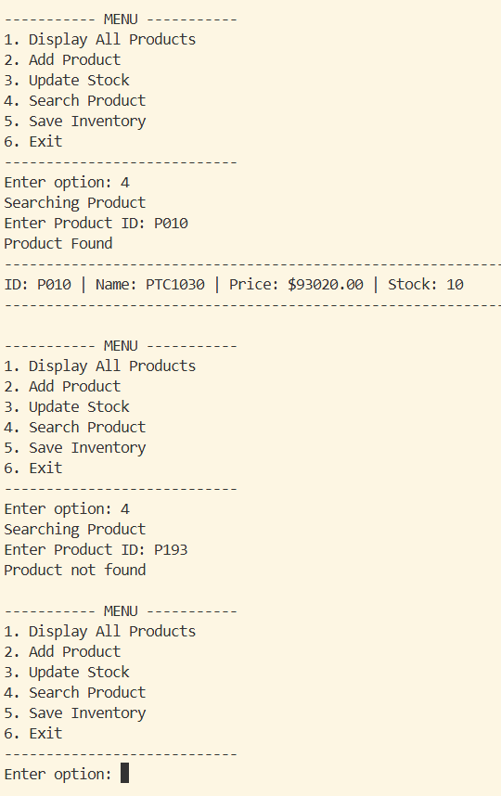
Docker Accepting Input and Output (Options 5 and 6) | 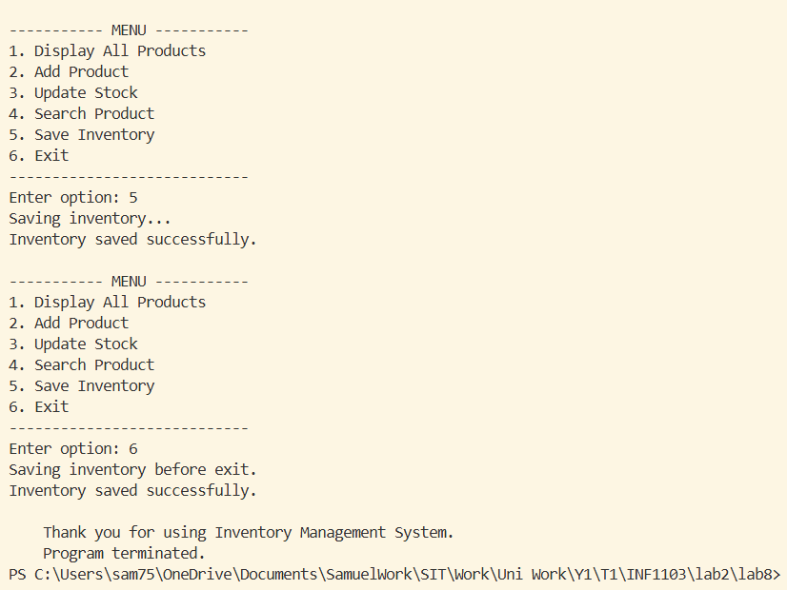
UML Class Diagram 1 | 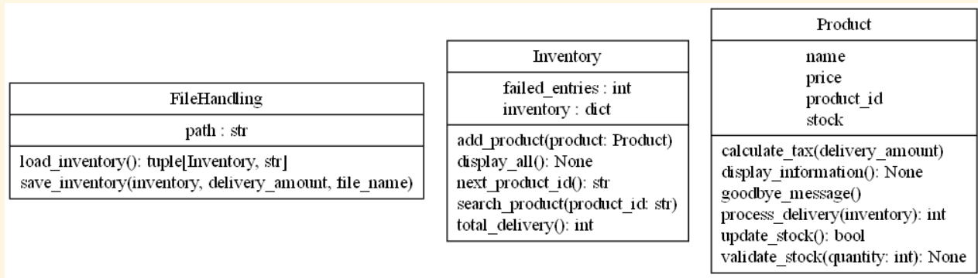
UML Class Diagram 2 | 